**📛** Project Name:

Author: PARESH RANJAN ROUT

**SmartAPIStreamX: Dynamic Multi-Source API Ingestion Framework & include intelligent AI-driven automation, smart debugging, and real-time alerting.**

**🧠 Project Overview:**

This project is a self-designed and advanced architecture built to solve a common yet **unsolved enterprise challenge:** ingesting data from multiple APIs with varying structures, **authentication methods**, **and destinations using a single dynamic pipeline with incremental load(reusable).**

It leverages Azure Data Factory (ADF), parameterization, and a metadata-driven strategy to dynamically control source, mapping, and target logic — creating a highly reusable, scalable, and automated ingestion system.

**My Own:** 💬 *“If I have multiple APIs from different companies or websites — like Fakestore, Facebook, YouTube, a company site, and a mobile app — and all have different structures and formats, how should I design my ADF pipeline to handle all of them?”*

**🧠 ✅ Core Challenge:**

* 🔁 **Different APIs** → Different base URLs
* 📄 **Different data structures** (some return flat JSON, others nested)
* 🧾 **Different auth types** (some public, **some need token**, some **OAuth**)
* 📊 **Different use-cases** (some go to SQL, some to Blob, some to Data Lake)

✅ Solution: Build a **Metadata-Driven API Ingestion Framework**

**📁 Folder Structure (GitHub / Local Dev)**

**📦 SmartAPIStreamX**

👤 linked services

│ ├── ls_http_fakestore.json

│ ├── ls_http_facebook.json

│ └── ls_http_youtube.json

👤 datasets

│ ├── ds_products.json

│ ├── ds_users.json

│ └── ds_carts.json

👤 metadata

│ └── api_metadata.json

👤 pipelines

│ └── api_ingestion_dynamic_pipeline.json

👤 sql

│ └── create_product_table.sql

👤 mapping

│ └── json_flatten_mapping_notes.md

└── README.md

**🎯 Key Objectives**

* Ingest data from **multiple APIs** (public, private, authenticated)
* Handle **different JSON structures**, including nested
* Route data to **multiple sinks**: SQL DB, Data Lake, Blob Storage
* Use a **single reusable pipeline** via ForEach + parameterization
* Minimize code duplication using **metadata control file**

**🧱 Core Azure Services Used**

* Azure Data Factory
* Azure SQL Database (sink)
* Azure Blob Storage (sink)
* Azure Data Lake Gen2 (optional)
* Azure Key Vault (optional for tokens)
* All the storage will be located different Geo Graphic area including on_pream ecosystem.

**🔁 Pipeline Flow Summary**

1. **Lookup Activity**: Reads metadata file
2. **ForEach Activity**: Loops through each API entry
3. **Copy Activity**: Fetches data using correct linked service & dataset
4. **Sink**: Writes to SQL / Blob / ADLS based on metadata

**💡 Future Enhancements & with AI & Automation**

🧠 **AI-Driven Logic Engine**:  
Integrate Azure AI + Log Analytics to **analyze logs and pipeline activity automatically**, identifying where logic breaks or fails — without needing to manually debug every activity.

🪲 **Smart Bug Detection System**:  
Build a logic-aware "error assistant" that can:

* Read error messages and pipeline logs
* Detect if the issue is: invalid token, wrong mapping, schema mismatch, null values, etc.
* Recommend a fix instantly (using pre-trained ML models or prompt templates)

🔍 **Visual Debug Assistant**:

* Add dynamic error tagging in your dashboard
* Show: Activity Name, API name, Failed Component, Exact Error, and Suggested Fix
* Example: ❌ CopyActivity | youtube_channels | Mapping error: rating_count missing

📬 **Automated Email Alerts**:

* Use **Azure Logic Apps** or **SendGrid** to send email when a pipeline fails
* Email includes:
  + ❗ Error Summary
  + ⏰ Timestamp
  + 🧱 Source API
  + 📍 Failed Step Name
  + 🛠 Suggested Fix
  + 🔁 Retry option link

📲 **SMS/WhatsApp Notifications**:

* Integrate **Twilio** or **Azure Communication Services**
* Get a message like:

‘’🔔 ADF Job Failed:

API: Fakestore | Step: Flatten Products

Issue: Column mismatch

Fix: Check 'rating' mapping’’

🧪 **AI Model for Root Cause Analysis (RCA)**:

* Train a simple model (on your own logs or sample pipeline logs)
* Let it predict whether the issue is source-side (API), mapping-side (ADF), or sink-side (SQL)
* Feed RCA into dashboard + alerts

**📌 Bonus Suggestions:**

* Add a **Log Table in SQL**:
* 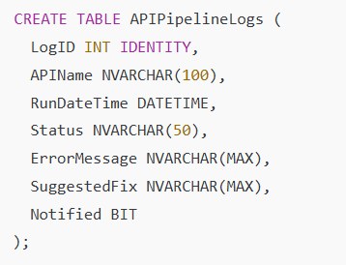

Add a **Toggle in Metadata** to control:

* If the API should alert
* If logging is enabled
* Alert level (info, warning, critical)

**✅ Final Statement**

* This project represents my vision to go beyond static data pipelines — and build a flexible, smart, and production-grade ingestion system that any large organization would benefit from.

**🚀 📐 SmartAPIStreamX V3: Enterprise-Grade Hybrid Automation Framework**

A fully automated, **cloud + on-prem**, **AI-ready**, **CI/CD-enabled**, and **self-healing** data ingestion system built with Azure Data Factory (ADF), Azure Monitor, Key Vault, Logic Apps, and optional Databricks or Synapse.

**🧠 SmartAPIStreamX – V3 Architecture Overview (Hybrid + Self-Healing)**

**📁 Data Sources**

**│**

**├── 🌐 REST APIs (Public / Private / Token)**

**├── 🏢 On-Prem SQL Server (via Self-hosted IR)**

**├── 📂 File Shares / SFTP / FTP / CSV / XLSX**

**│**

**▼**

**🔍 Metadata Control Layer (JSON / SQL Table)**

**• SourceType, AuthType, SinkType, Token, FileFormat**

**• Target Table, TransformationRequired, Schedule**

**│**

**▼**

**🔁 ADF Control Pipeline**

**├── 🔎 Lookup Metadata**

**├── 🔁 ForEach Loop on Source**

**│ └─ 💡 Conditional Logic:**

**│ ├─ ✅ Copy API**

**│ ├─ ✅ Copy SQL**

**│ ├─ ✅ Copy File**

**│**

**▼**

**🔁 Staging (Bronze Layer)**

**📦 Blob / ADLS Gen2**

**• Raw JSON, CSV, XLSX**

**│**

**▼**

**🧪 Data Quality Validation / Transformations (Silver)**

**• ADF Data Flow / Azure Databricks / PySpark / Mapping**

**│**

**▼**

**🏛️ Data Warehouse (Gold Layer)**

**🟡 Azure Synapse Analytics (SQL Dedicated Pool)**

**🟡 Azure SQL Database**

**🟡 Delta Lake (if Databricks used)**

**• Fact + Dimension Model**

**• Surrogate Keys, Slowly Changing Dimensions (SCD)**

**• Partitioned Tables**

**• Materialized Views**

**│**

**▼**

**📊 Power BI / ML**

**• Real-time dashboards**

**• Semantic models**

**• Machine Learning pipelines**

**│**

**▼**

**🧠 Monitoring + Auto-Heal Layer**

**• Log failures → Azure SQL + Azure Monitor**

**• Logic App sends alerts (Email, Teams, SMS)**

**✅ Key New Features in V3**

| Feature | V3 Supports It? | Description |
| --- | --- | --- |
| 🌍 Hybrid Sources (API + On-Prem) | ✅ | REST + SQL Server + File shares |
| 🔀 Source-Type Switching | ✅ | Controlled via metadata field: dataSourceType |
| 🔐 Key Vault Integration | ✅ | Secure token injection for APIs |
| 🧠 Auto-Healing Alerts | ✅ | Azure Monitor + Logic Apps + optional ML |
| 🧱 Transformation Layer | ✅ | Built-in ADF Data Flow or external Spark |
| 🚀 CI/CD Ready | ✅ | ARM templates or Bicep for version control |
| 📦 Unified Metadata-Driven Logic | ✅ | APIs, SQL, Files handled in 1 loop |
| 📋 Data Quality Checks | ✅ | Null check, record count match, schema match |
| 🔄 Incremental Loads | ✅ | Watermark columns, last_load, current_load |

**🛠 Technologies Used**

| Azure Service | Purpose |
| --- | --- |
| Azure Data Factory | Orchestration + ingestion logic |
| Self-Hosted IR | To access on-prem SQL/file shares |
| Azure Key Vault | Token/secret management |
| Azure Blob/ADLS Gen2 | Storage for Bronze/Silver/Gold |
| Azure SQL / Synapse | Final Gold Layer / warehousing |
| Azure Monitor | Logs, metrics, alerts |
| Logic Apps / Twilio | Email/SMS/WhatsApp alerts on failure |
| Databricks / Data Flow | Transformations (flattening, joins, etc.) |

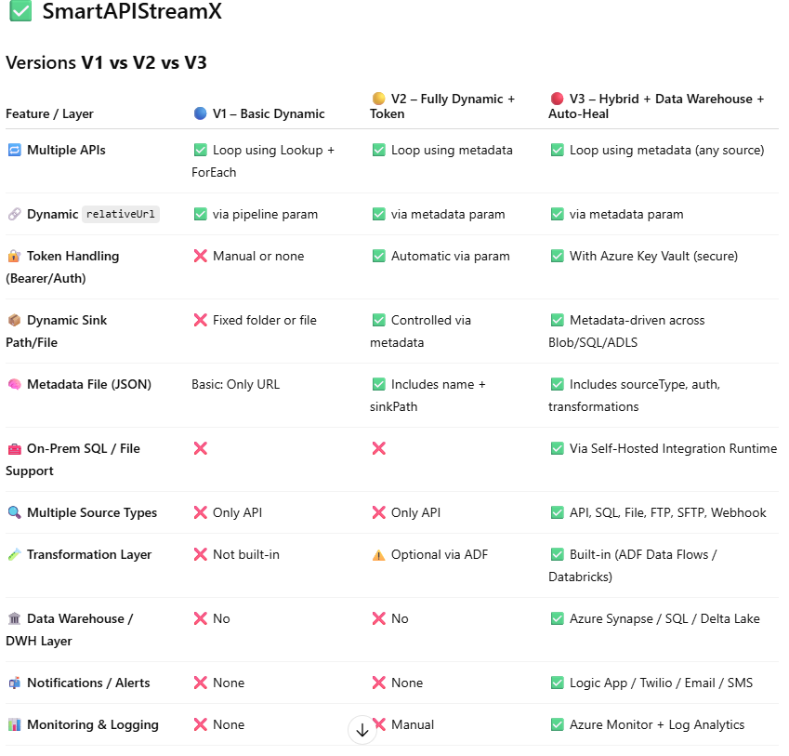

**🧠 Summary**

| Version | Best For | Key Focus |
| --- | --- | --- |
| V1 | Learning, small projects | Understand dynamic API ingestion |
| V2 | Portfolio, token APIs, job interviews | Dynamic pipelines & metadata |
| V3 | Real production, hybrid enterprise | Full orchestration, AI-ready, warehouse included |